ATIC Accessibility
To support the accessible community in making informed travel decisions for their individual needs

This report prepared for:
Business name: | Murujuga Aboriginal Corporation
Address: | Lot 501 GRIFFIN ROAD
Town: | DAMPIER
Contact for enquiries: | Heather Osborne
Contact Number: | 0410 520 998
Contact Email: | rsm@murujuga.org.au
Website: | www.murujuga.org.au
Date: | 2025-11-19 17:03

ATIC Accessibility
The following pages provides travellers with information on the businesses facilities and amenities which aims to support the traveller to make an informed decision on whether the business is suitable for their individual needs.
OVERVIEW 4
Business Overview 4
Bookings 4
Communications 4
Guide Dog and Service Animals 5
GENERAL 6
Pre-arrival, arrival and reception 6
Cognitive Impairment Support 6
Car Park and Access amenities 6
Displays, exhibits, commentary and live performances 6
External Paths 7
Steps 7
Ramps 7
TOUR OPERATORS 8
Route Planning 8
Guides 8
ATTRACTIONS 9
COMMON AREAS 11
Report Disclaimer 13

OVERVIEW

Business Overview

The business has the following products/services available
- Tour/Transport
- Attraction

Our business caters for the following disability types:
- Limited mobility
- Wheelchairs or mobility scooters

Bookings

The business offers the following methods for bookings and enquiries:
- Phone
- Email
- Webportal

Site is outdoor and open at all times to any member of the public. When guests come on a guided tour the tour guide provides a safety briefing at the start of the tour which will be the same egress and evacuation point for all people including those with a disability.

Communications
- Our business offers the following alternative communication methods
- Plain English

Not specified
- There is easy to read signage and information (e.g. menus and emergency information)

Guide Dog and Service Animals
- The business provides a toilet area for service animals
The business provides the following services for services animals:
Not specified

GENERAL

Pre-arrival, arrival and reception
The business has the following in place to support guests during pre-arrival, arrival and reception
- Booking information and websites are compatible with screen readers
- In addition, the following further information can assist guests:
There is no wait time. The site is always open and accessible. There is a shaded part with benches or room for a wheelchair for those who become tired moving around the site.&nbsp;
- In addition, the following further information can assist guests:
The site is always open and accessible. There is a shaded part with benches or room for a wheelchair for those who become tired moving around the site.

Cognitive Impairment Support
- Documents are available in plain English for people with cognitive impairment (This may include instructions, guides, menus and general information)

Car Park and Access amenities
The business has the following Car Park and Access amenities
- A drop off zone
- Designated disabled parking bays
- Level or ramped access from the car park to the entrance
- The accessible entrance is clearly signed from the parking bay
- Kerb ramps are in place where a pavement or walkway needs to be crossed

Displays, exhibits, commentary and live performances
For displays, exhibits, commentary and live performances the following amenities are in place
- Seating
- Wheelchair accessible spaces/seating

External Paths
External paths of travel have the following amenities are in place
- Surfaces are concrete, asphalt, smooth paving or hard packed fine gravel (max aggregate size 13mm)
- Pathways are wider than 900mm
- There 3 successive steps or less on any path or at any doorway

The path diverges to the same point. One way is a wheelchair accessible ramp. The other is stairs. They meet up at the same point.

Steps
Steps have the following amenities are in place
- There are steps.
- Top and bottom steps are easily distinguished through colour contrast or the use of TGSIs (Tactile Ground Surface Indicators)
- All steps or staircases have enclosed risers
- The underside of all staircases are enclosed or protected to a height of at least 2 metres
- Handrails fitted to all open sets of steps

Ramps
Ramps have the following amenities are in place
- There are ramps.
- All fixed ramps are 1:14 or less
- Long ramps (more than 10m) are 1:20 or less
- Ramps have a raised edge of at least 100mm

TOUR OPERATORS

Route Planning
- Walking Tours
- Multi-paced to account for slower walkers
- Electronic voice augmentation

Guides

Guides have been trained in the following
- Use of clear/simple English
- Correct pronunciation for lip readers
- There is a audio description of surroundings

ATTRACTIONS
  - Image(s)
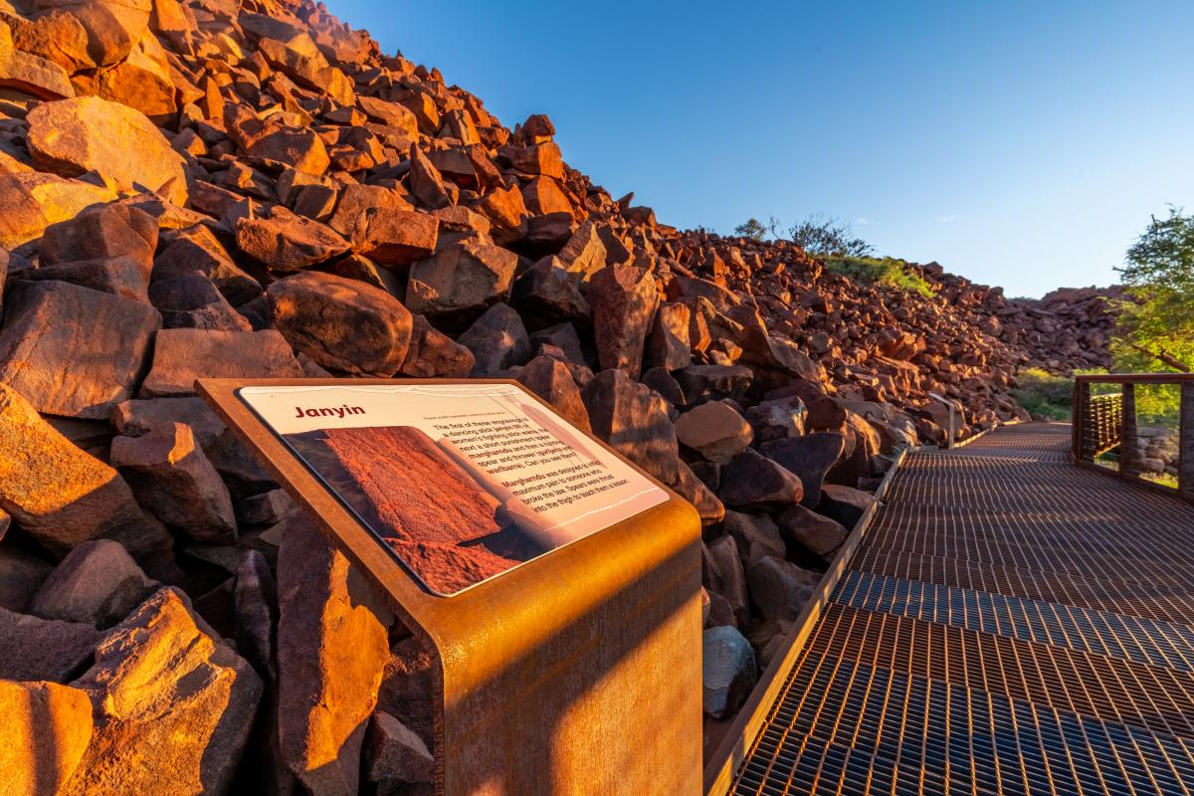
murujuga-national-park-fuzz-digital5
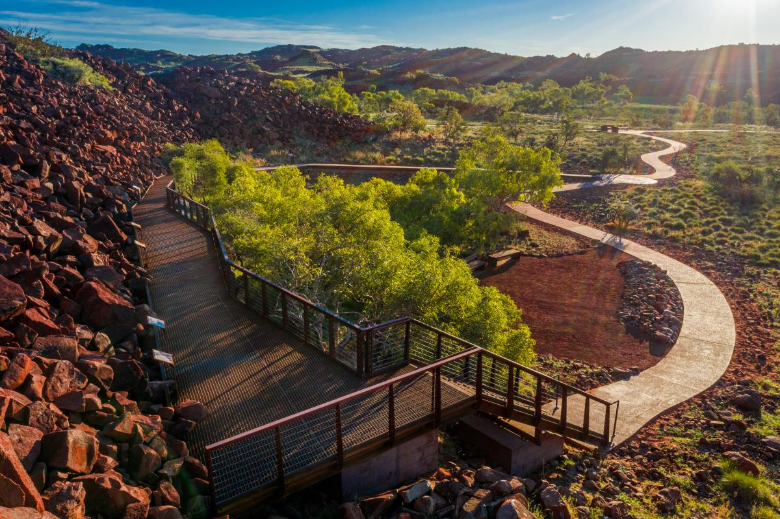
murujuga-national-park-fuzz-digital1
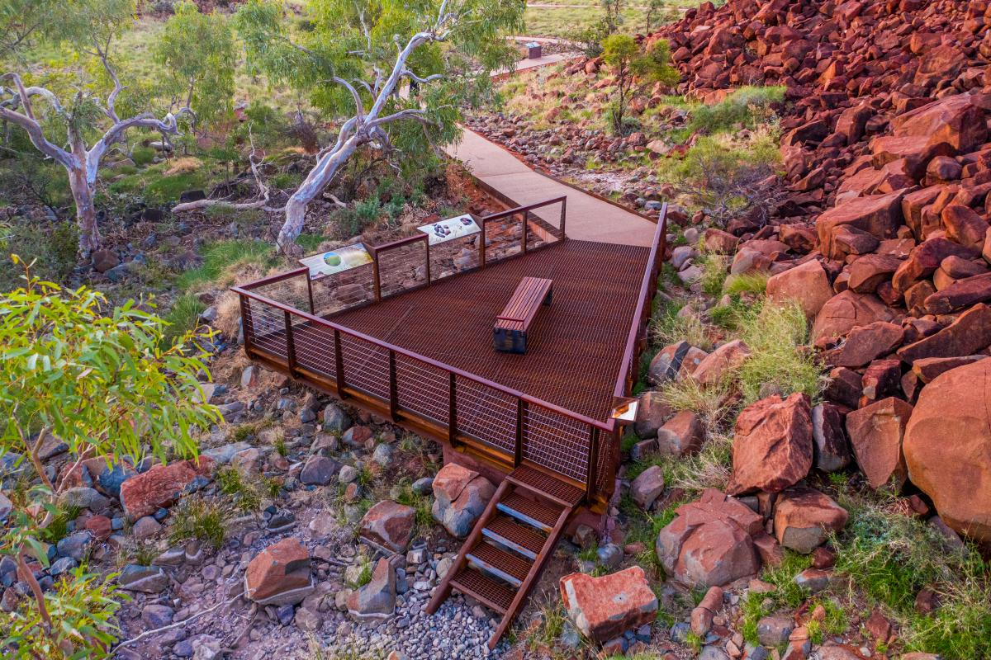
murujuga-national-park-fuzz-digital12
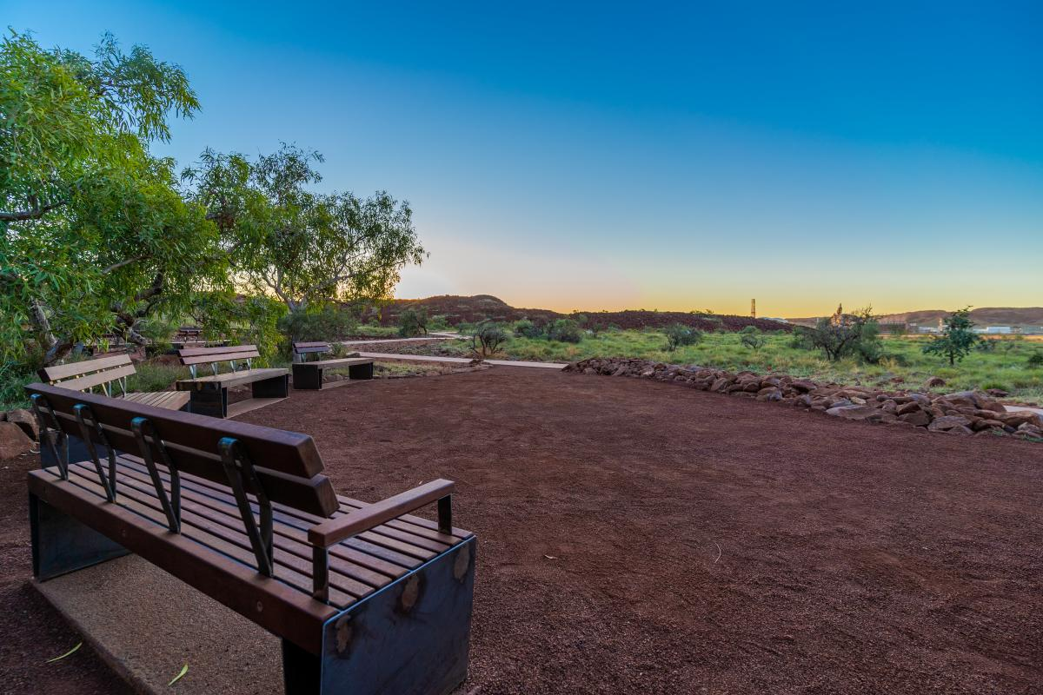
murujuga-national-park-fuzz-digital10 (1)

COMMON AREAS

Report Disclaimer
Please note that this business report, provided as a result of the use of the diagnostic assessment, is for information purposes only.
Australian Tourism Industry Council (ATIC) cannot guarantee the accuracy of respondent’s answers, or that they are fully representative of your business. Therefore, ATIC does not warrant or guarantee any particular outcome in respect of your businesses self-assessment.
This report is intended as guidance only for your business and should not be relied on for future marketing considerations. ATIC recommends that you seek your own independent advice as well as the results from the diagnostic.
Links to external web sites are inserted for convenience and do not constitute endorsement of material at those sites, or any associated organisation, product or service.
ATIC does not:
- Assume any legal liability for the accuracy, completeness, or usefulness of any information from this report or any links provided; or
- Accept responsibility for any loss associated directly or indirectly from the use of this report.

